Performance Testing
Date | 03 October 2026
Team ID | SWTID-2026-7859
Project Name | EduGenie: Google Gemini Powered Learning Assistant
Maximum Marks | 5 Marks

Performance Testing
Performance testing evaluates how EduGenie behaves under expected and peak load. Tests were run with the project's own asynchronous load-test script (EduGenie/tests/load_test.py).
Step 1: Testing Overview
Field | Details
Testing Tool Used | Custom Python load tester (tests/load_test.py, asyncio + httpx); pytest for functional tests; psutil for CPU/memory
Type of Testing | Load testing (10 concurrent users) and stress testing (50 concurrent users)
Target Module / API | GET /, GET /health, GET /qa, POST /explain, POST /quiz, POST /summarize, GET /learn/recommendations
Test Environment | Local - Uvicorn (1 worker) on a 4-core / 15.7 GB Linux machine. The Gemini call was replaced by an instant stub to measure EduGenie's own server overhead (end-to-end AI latency depends on Google's API and the key's quota).
Test Date | 01 October 2026

Step 2: Test Scenarios
S.No | Test Scenario / Description | No. of Virtual Users | Duration (sec) | Expected Outcome
1 | Home page and health check load (GET /, GET /health) | 10 | 10 each | Avg < 2 s, 0% errors
2 | All five AI endpoints under normal load (Q&A, explain, quiz, summarize, learning path) | 10 | 10 each | Avg < 2 s (server overhead), 0% errors
3 | Stress test on the most-used endpoints (Q&A and quiz) | 50 | 10 each | No failures, max < 5 s
4 | End-to-end test with the live Gemini API (python tests/load_test.py --users 5 --duration 30) | 5 | 30 | AI responses within ~10 s; limited by the API key's rate limit

Step 3: Performance Test Results
S.No | Metric | Target Value | Actual Value | Status (Pass / Fail) | Remarks
1 | Response Time (Avg) | < 2 seconds | 11-12 ms (10 users); 51-58 ms (50 users) | Pass | Server overhead only (Gemini stubbed)
2 | Response Time (Max) | < 5 seconds | 218 ms | Pass | Worst case across all scenarios
3 | Throughput (Req/sec) | - | 824-985 req/s | Pass | Single Uvicorn worker
4 | Error Rate | < 1% | 0.0% | Pass | ~77,000 requests, no failures
5 | CPU Utilization | < 80% | 14.5% peak (of 4 cores) | Pass | Measured with psutil during load
6 | Memory Utilization | < 80% | 54 MB (0.3% of RAM) | Pass | Lightweight - no local model loaded
7 | End-to-end AI response (live Gemini) | < 10 seconds |  |  | To be measured with a live API key (scenario 4)

Step 4: Observations & Analysis
- EduGenie's own processing (routing, validation, prompt building, JSON parsing, response) adds only ~12 ms on average, so total response time is dominated by the Gemini API.
- No errors occurred at 50 concurrent users; blocking Gemini calls run in FastAPI's thread pool, keeping the server responsive.
- Memory use stays very low (~54 MB) because AI inference runs in Google Cloud; enabling the optional local LaMini-Flan-T5 model adds roughly 3 GB.
- For production scale, run several Uvicorn workers or containers behind a load balancer; the stateless design makes horizontal scaling straightforward.
- Gemini overload (HTTP 503 'high demand') and free-tier rate limits (HTTP 429) are the most likely bottleneck under real load; EduGenie retries automatically with exponential backoff, falls back to backup models and otherwise shows a clear message with a Try again button.
Step 5: Screenshots / Evidence
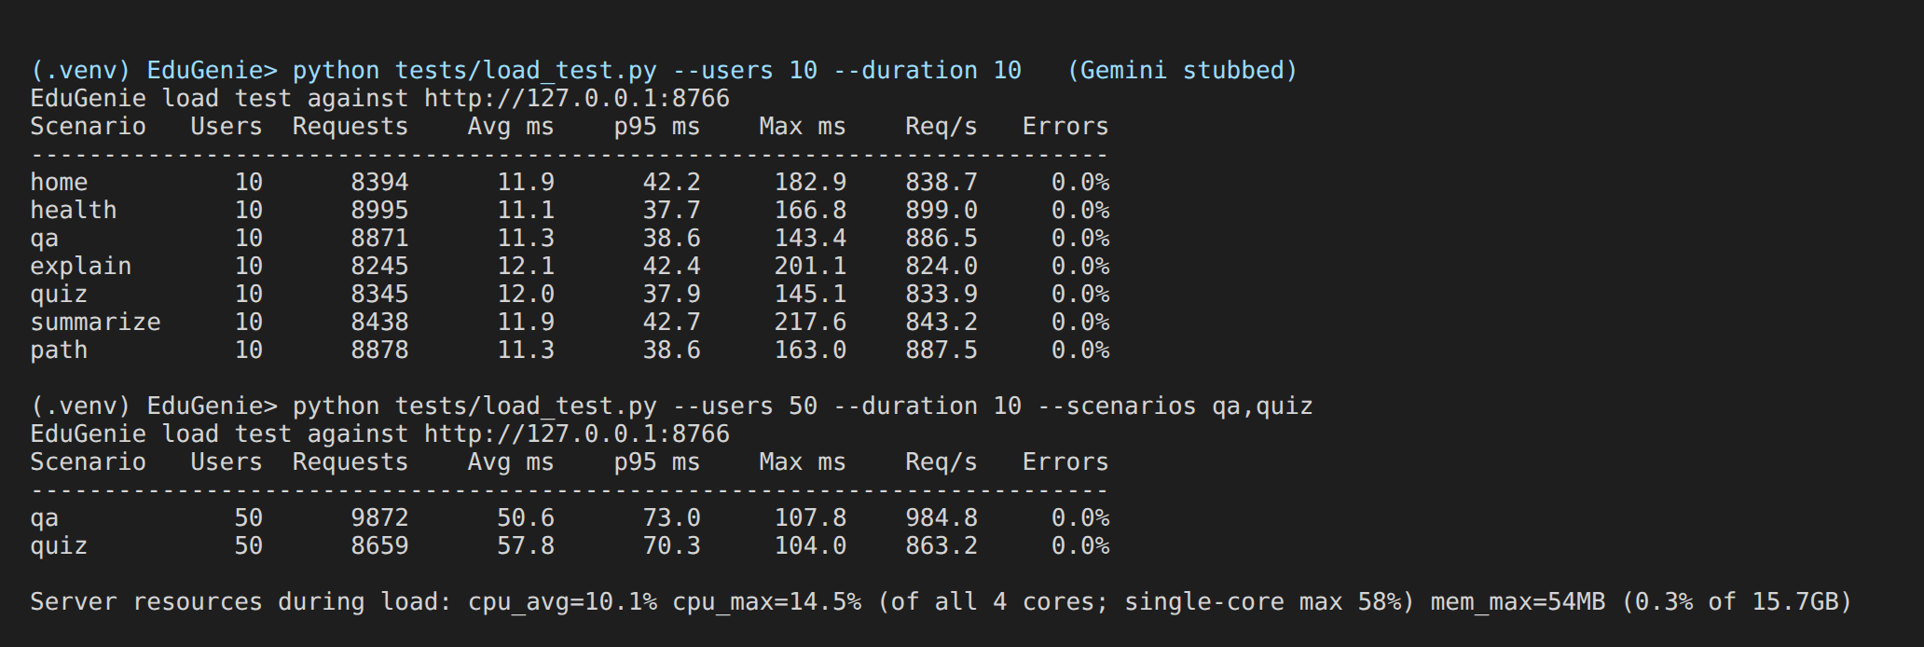
Load test output (tests/load_test.py) with server resource usage
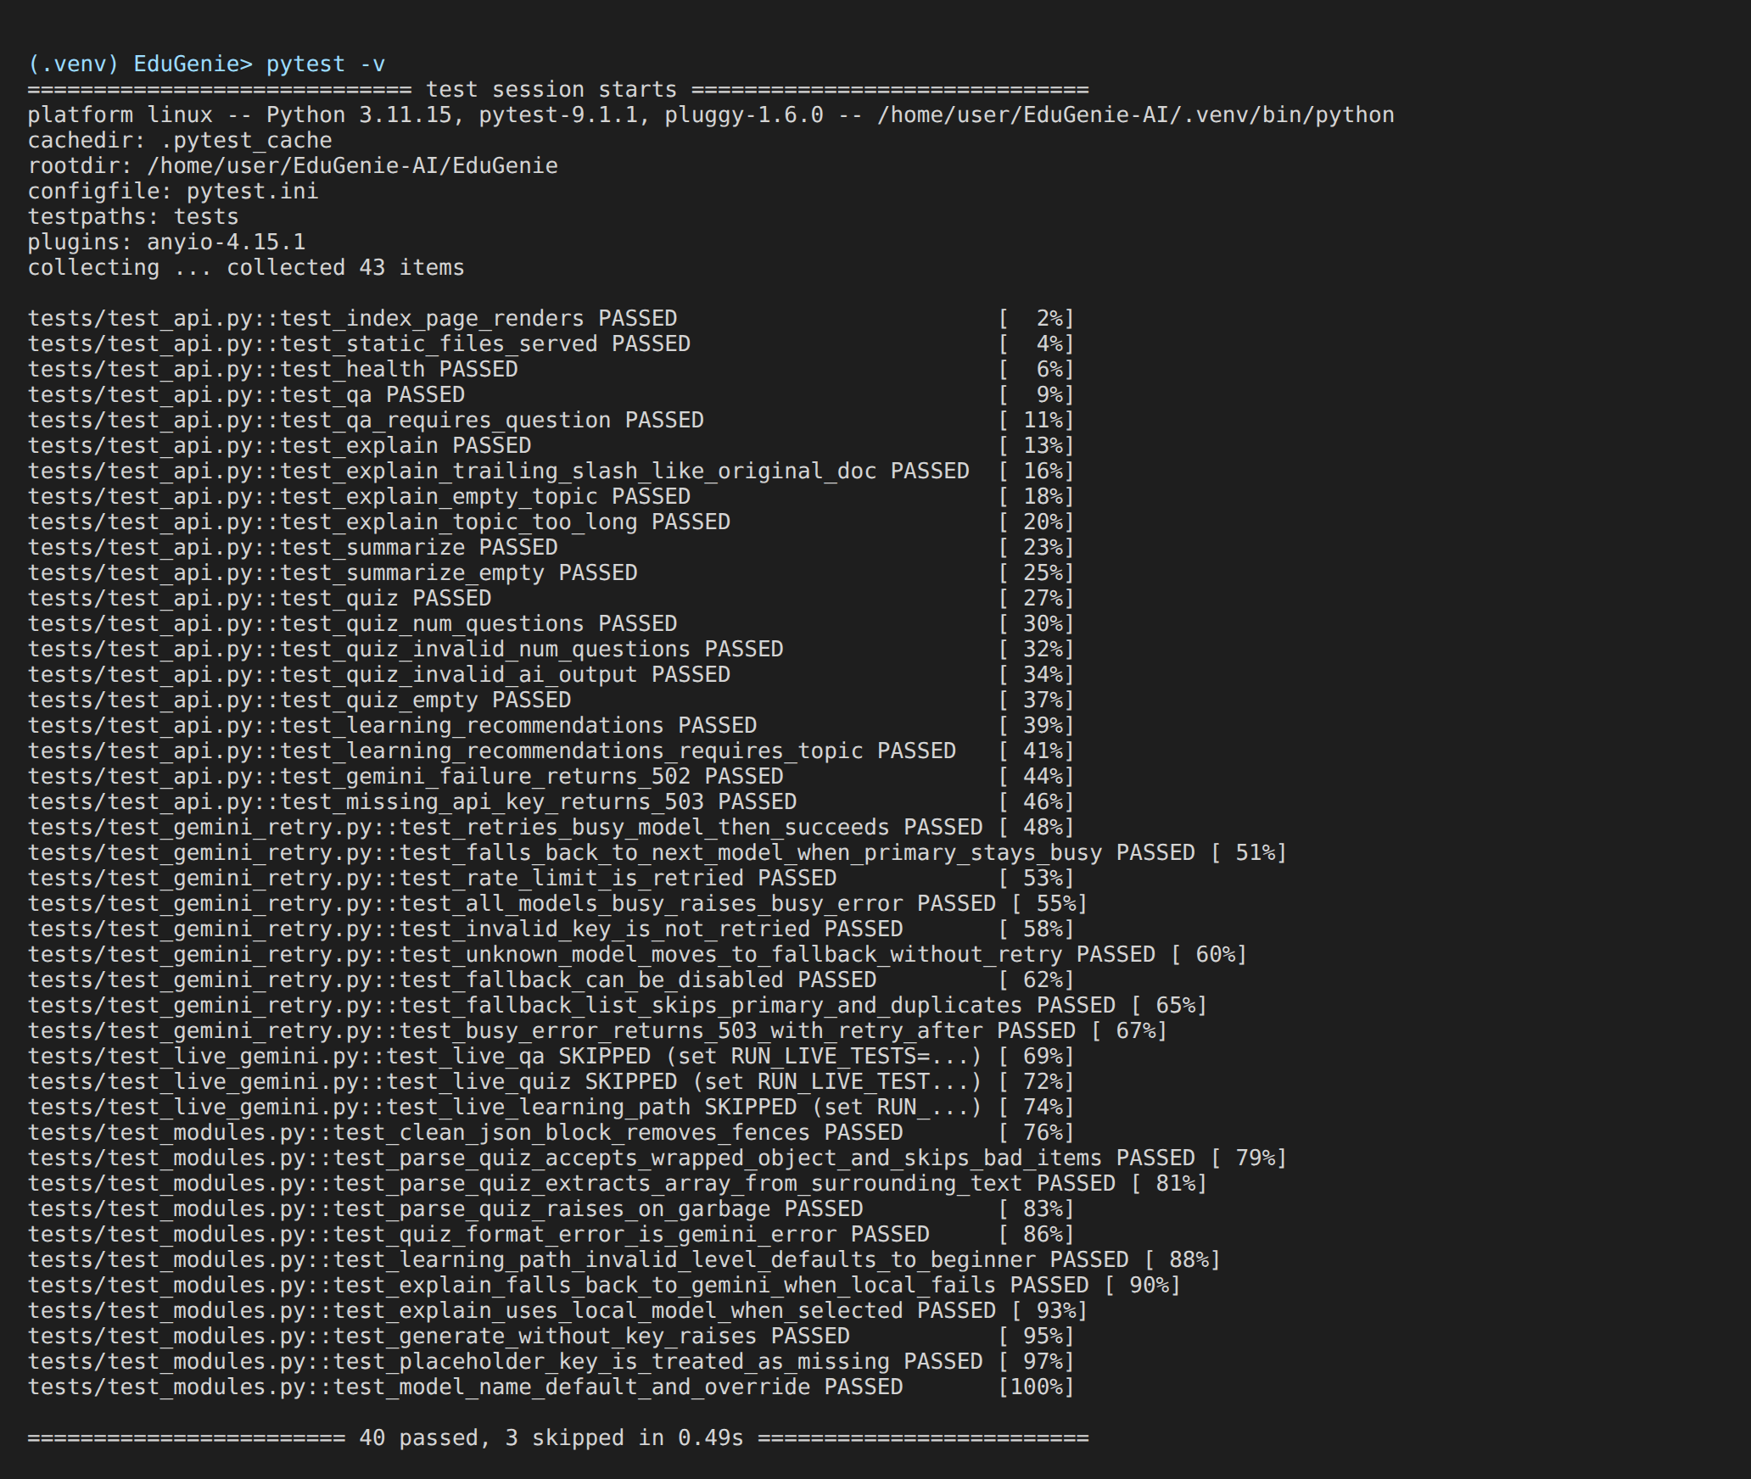
Functional test suite: 40 passed, 3 live tests skipped (require API key)

